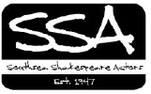
Billboard
From the Chair . . .
Dear Member,
What a week it has been in the life of the SSA as we celebrate the 400th anniversary of the Bard’s birth and death later this month on the 23rd April and start to look forward to the 70th anniversary of the company in 2017. As I write, I feel very proud of the SSA’s achievements over nearly seven decades. Of course we chose to mark Shakespeare’s 400th centenary with a major production and, sitting in the audience to witness Nick Downes’s superb production of “The Winter’s Tale” at the Square Tower in Old Portsmouth, I became very aware of the company’s true diversity of experience and new energy. We can look forward to our Autumn 2016 season with excitement. Read further as we prepare to challenge our verse speaking skills in Lauren Farnhill’s offering of T S Eliot’s “Murder in the Cathedral” at the Portsmouth Cathedral in October as part of the Cathedral’s patronal festival, and transport you to the Forest of Arden for Shakespeare’s wonderful pastoral comedy, “As You Like It” at the Station Theatre in Hayling Island in November, directed by Paula Bartlett and Ellen Giddey.
Also, as a member of the company, PLEASE come to our Annual General Meeting on Tuesday 17th May 2016 at 7.30 p.m. at the HQ in Omega Street (read more in this Billboard). This is a statutory requirement for us as a registered charity, but also a chance for you to confirm your commitment to the company, pay your subs, and have your say as to what YOU think we should be doing in 2017, the 70th anniversary of our birth.
But above all, whatever you are doing on Saturday 23rd April 2016, please raise a glass in celebration of the life and works of the Bard of Stratford upon Avon, William Shakespeare, who to a great extent is the reason behind what we are as a company and why we do what we do.
Best wishes and happy birthday William Shakespeare,
Terry Wiseman,
Chair,
The Southsea Shakespeare Actors

Expo Expo ...!!
They are like buses – you get none for ages then two turn up at once!!
Yes, coming up in the next fortnight are TWO exciting launches of the SSA’s Autumn 2016 season.
PLEASE come along to BOTH and find out about the flexible and diverse opportunities available for performance and involvement in our next two shows, as we gear up for next year as well – the SSA’s 70th season!!

Expo One - “Murder in the Cathedral”
By T S Eliot directed by Lauren Farnhill and James Rowland.
Monday 25th April at 7 p.m. in the Portsmouth Cathedral, High Street, Old Portsmouth (opposite the Dolphin pub),
Performance dates: Saturday 1st and Sunday 2nd October, 2016 in the Portsmouth Cathedral, High Street, Old Portsmouth
This classic and seldom performed text, written in 1935 and set in 1170, is Eliot’s first full-length play and is felt by many critics to be his most successful attempt at combining the needs of poetry with those of live drama. It portrays the assassination of Archbishop Thomas Becket in Canterbury Cathedral in 1170 and it is very exciting for the SSA to be invited to perform this in the City’s Anglican Cathedral of St Thomas as part of their patronal festival. Indeed Becket’s internal struggle is the main focus of the play.
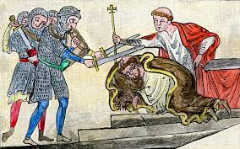
There are male roles available as Thomas himself, plus priests, tempters and knights (who famously and dramatically commit the murder of Thomas on the steps of his own Cathedral). There is also a wonderfully powerful chorus of female roles as the women of Canterbury who, as in Greek drama, are a key feature and offer comments about the action, providing a link between the audience, characters and action.
The performance will be costumed in full 12th century dress and Dr David Price, Head of Music at the Cathedral, will be directing a group of his male choristers in traditional “plainsong” style to accompany the various events which take place during the course of the action.
Please come along TO THE CATHEDRAL (NOT HQ) on Monday 25th April at 7 p.m. to hear more about this exciting opportunity to work on and develop your verse speaking, wear full 12th century costume and perform in the wonderful (and challenging) setting of the Portsmouth Cathedral.
Lauren Farnhill and James Rowland

Expo Two - “As You Like It”
By William Shakespeare directed by Paula Bartlett and Ellen Giddey.
Wednesday 27th April at 7.30 p.m. in the SSA HQ, Omega Street, Portsmouth
Performance dates: Wed 9th to Sat 13th November 2016 at the Station Theatre, Hayling Island.
As You Like It is one of Shakespeare’s great comedies and the heroine, Rosalind, is one of his most inspiring of Shakespeare's female characters. Rosalind, the daughter of a banished duke falls in love with Orlando the disinherited son of one of the duke's friends. When she is banished from the court by her usurping uncle, Duke Frederick , Rosalind takes on the appearance of a boy calling herself Ganymede. She travels with her cousin Celia and the jester Touchstone to the Forest of Arden, where her father and his friends live in exile.
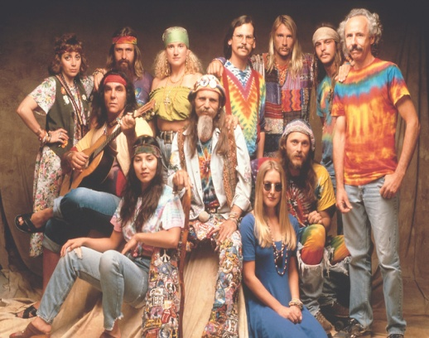
Themes about life and love, including aging, the natural world, and death are included in the play. Much hilarity ensues, new friends are made and families are reunited. It also features the great soliloquy which begins:
"All the world's a stage
And all the men and women merely players;
They have their exits and their entrances,
And one man in his time plays many parts"
We will be setting the play mostly in woods with a sixties/seventies hippy theme – but don’t worry it’s not going to be like Hair! Everyone will keep their clothes on!
Paula Bartlett and Ellen Giddey

Ruff Fashion Show
Cast from “The Winter’s Tale” will be performing at the Ruff Fashion Show . . .
Details here about this exciting show which is part of the “Much Ado about Portsmouth” initiative, taking place at the Square Tower in Old Portsmouth on Friday 22nd April. Our own wardrobe team – Lauren and Annie – are judges and if you click the link given below you can find out about how to buy tickets for the evening.
The Ruff Fashion Show features young designers wanting to show off their versatility by fusing the modern with the Shakespearean. Collections will include a nod to Shakespeare as part of the Much Ado About Portsmouth festival week, which celebrates the times and achievements of England's most famous playwright. The show takes place in Portsmouth's wonderfully atmospheric Square Tower – the perfect venue to inspire! – and includes energetic performances by local dramatic groups and street dancers. The designs will be judged by experts from the University of Portsmouth and prizes range from a spread in an international magazine to a professional photo-shoot. This promises to be a glittering and exciting evening, so be sure to come along to see the special pieces our talented designers have created.
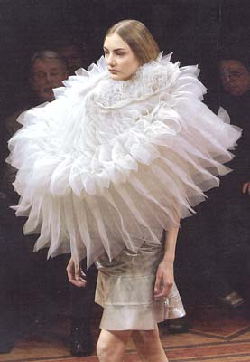
Location: Square Tower Broad St Portsmouth Hampshire PO1 2JE
Date: Friday 22nd April 2016
Time: 6:00pm to 9:00pm Guests should arrive at 5:30pm
Festival Website: www.maap.port.ac.uk/index.php

OMG SSA AGM
Annual General Meeting of the SSA, 19:30 Tuesday 17th May 2016 in the SSA HQ at Omega Street, Portsmouth
Yes it’s that time of year again – but just in case you have forgotten what the excitement is all about, here are a few words from the lovely and talented Mr James Rowland... So James what’s the AGM for?
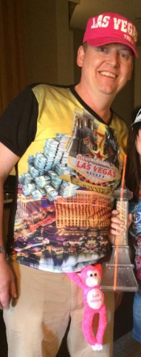
1. It is a chance to discuss and vote on issues that are important to the company. Every member will be given the opportunity in the next few weeks to formally propose items for the agenda. Note that items not on the agenda can be discussed during the AGM, but can't be voted on or passed into the constitution of the SSA
2. The AGM is also the opportunity to choose the committee for the coming year. Our committee is made up of 3 elected officers - the Chair, Treasurer and Secretary - plus 7 general members, some of whom have specific responsibility (website, business, charity commission etc). Each officer is elected for a 3 year term, whilst the general members are elected annually.
3. In the next couple of weeks you will receive a mail-out from our secretary, Courtney. The mail-out will advise you on the process for proposing agenda items for the AGM. It will also detail which officers are at the end of their 3 year term and whether they have offered to stand again or not, which general members of the committee have offered to stand again, and how to be nominated should you wish to join the committee. If there are more people nominated than committee places available, an election will be held during the AGM
So there you have it! Dare you miss it!!

Reviews of “The Winter’s Tale”
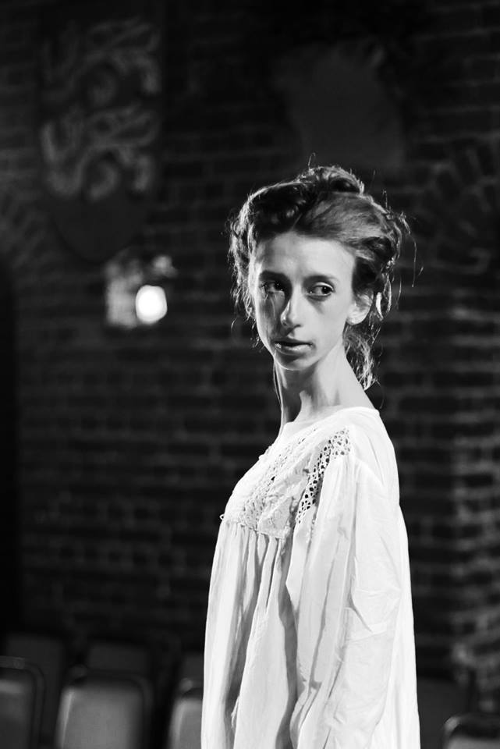
Review by Ed Howson of So’ton Daily Echo.
“Only one word can describe this sublime production of jealousy, loss, penitence and reconciliation – perfect !
Director Nick Downes’ Edwardian staging (immaculately costumed by Lauren Farnhill and Annie Sayle), with its atmospheric lighting and sound and its simple but effective choreography, showcased an impressive depth of acting talent from Andy Thomas’s irrationally jealous King Leontes and Susie Coutts as the wrongly-accused but dignified Queen Hermione, to the marvellous rustic double-act that was Tim Suffolk’s Old Shepherd and Aaron Holdaway as his son.
Romance was beautifully realised by Stuart Williams’ Prince Florizel and Lara Cooper-Chadwick’s foundling Princess Perdita, with comedy and songs from Danny Carter’s itinerant rogue Autolycus.
Wonderful characterisation, too, from Rob Bartlett as Polixenes, King of Bohemia, and Patric Howe as Leontes’ right-hand man Camillo, while Sarah Parnell, as the faithful Paulina, brought about the final deeply-moving reconciliation that had members of the audience wiping away their tears.”

Review by James George – The News
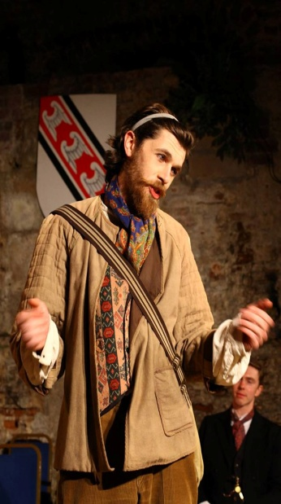
"The Winter’s Tale is one of Shakespeare’s lesser-known plays and, as such, the cast are under no pressure to do anything other than tell the story.
And The Southsea Shakespeare Actors did just that – with style, creativity, clarity and warmth.
Director Nick Downes had assembled a mighty cast.
Andy Thomas and Rob Bartlett as Leontes and Polixenes – kings and friends who fall out in no uncertain terms – are the foundations upon which the plot is built. Thomas conveyed the agonies of jealousy with studied excellence and Bartlett’s betrayed friendship matured credibly into bitterness and anger.
The women, here, came off particularly well.
Susie Coutts as the wronged Hermione and Sarah Parnell as the faithful Paulina gave astonishing, controlled performances of strength and integrity – but they had best watch out for up-and-coming Lara Cooper-Chadwick (Perdita) whose performance had gravitas, truth and subtlety far beyond her years.
Tim Suffolk and Aaron Holdaway made the notoriously difficult Shakespearean comic roles funny – always worthy of praise! – but the crowning glory of the piece, thanks to inspired direction, was the almost-wordless reconciliation between friends and family at the end of the play.

Review by Matt Gibbins - Curtain Up South
This week saw The Southsea Shakespeare Actors perform one of Shakespeare’s lesser known tales to sell out audiences at one of Southsea’s more beautiful venues.
If ever there was one, this production, led by the highly capable director Nick Downes, proved to be a masterclass in how to put on Shakespeare to a modern audience. Set against the authentic backdrop of The Square Tower, with beautiful lighting by Alex Musgrave and emotive sound and music by Downes himself, the delivery and understanding of the text was undoubtedly of the highest standard, which incidentally helped their audience follow the story with much ease. The only criticism one might draw from the evenings entertainment was that a very small portion of the text, at times was lost, due to some questionable accent choices. But to criticise this production at all would be a considerable stretch.
Andy Thomas provided a remarkable portrayal of Leontes, showing an unfathomable range of depth of emotion. His onstage counterpart Rob Bartlett balances the pairing with a weighted and earthly Polixenes, the two complimenting each other fantastically. A much welcomed comedy distraction was provided by a strong duo act consisting of Aaron Holdaway’s Young Shepherd. His comedic timing and seemingly endless catalogue of facial expressions engaged the audience and kept them laughing throughout, while Danny Carter’s Autolycus gave us a wide range of different con-artist characters proving what a strong and widely diverse young actor he is. A special mention must also go to the young Joe Bartlett, making his stage debut and proving that, if he chooses to do so, he has a highly promising career ahead of him.
This production, however, belongs to the female members of the cast. Sarah Parnell as Paulina dominated the stage and every man on it with little to no effort. Lara Cooper-Chadwick gave a performance considerably far beyond her years, as the young and beautiful Perdita, displaying a level of acting wisdom that we can only hope will continue to flourish and grow in future roles. The absolute star of this production however is Susie Coutts as Hermoine. Rarely have I seen an actress who performs with such delicacy whilst also remaining determined and grounded. So little often do we get to see such inherently strong female roles performed to such a high quality and Coutts steals the entire show, both in delivery and physical ability.
Downes has once again proven that, AmDram company or not, that there is a wealth of talent to be found that can rival that of a west end stage with ease.

